^{on} Sermon 26November 2017 “Christ Is Among Us’
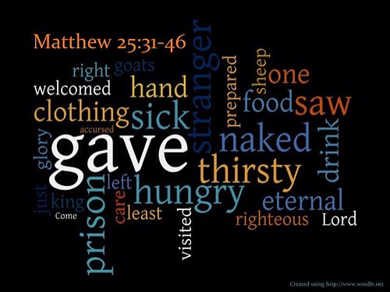
Ezekiel 34:11-16, 20-24 Matthew 25:31-46

Prayer: Gracious God, in everyone-each-us-will-meet and to everyone each-of-us-teach, may we feel your presence in them, and greet them as we would a close friend, a companion on the road. Amen. ^{off}


I know it sounds funny – but today is the last Sunday of the Church year. ^{on} It’s because we start our Church year 4 weeks before we celebrate Jesus birth, and the ancient ones of our faith determined that the 25th of December would be “THE DAY” of that celebration. We have 4 weeks to spend working up to it!

As this is the last of our year – it also means it is the last Sunday of Year “A” of the three year Gospel cycle we follow, by this, I mean that in Year ‘A” most of our Gospel Texts are from Matthew. So for most of the year our Sunday reflections have Matthew’s perspective / priorities, Matthew’s understanding of what and who and why of his friend, his master, his Lord: Jesus…. Next Year – we will follow Mark (with John filling in)… but that’s next year!

Today we have the chapter 25 from Matthew; it’s the final, the climax of his reports, his version of the Gospel of Jesus Christ. ^{3*}Jesus last week has just begun; it’s nearly time for ‘that’ Passover meal and all the events that follow as we remember in our Easter observances.

So like any writer, Matthew’s conclusion contains the matters which are ^{1*}central to his understanding and what are for him the most significant revelations of Jesus. What ^{2*} began with the Sermon on the Mount and the ‘Beatitudes’ in chapter 5, is finished in Chapter 25. What Jesus began in pronouncing blessing on the despised and bereft, the poor and marginalised, the weak and voiceless… now at the close of his ministry, in this chapter announces that his presence is in them, the ‘blessed ones’.”
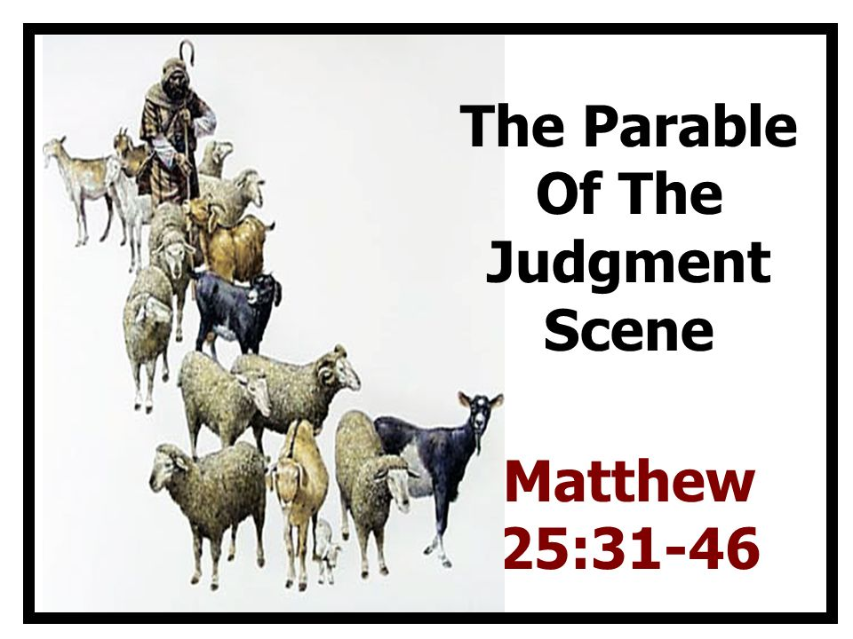

For Mt, all ^{3*}Jesus parables about the Kingdom of God at the beginning of his ministry are completed in the parable of a great judgement. ^{on} ^{3*}“Jesus identified 5 characteristics of God’s saving action: it is all-embracing; inexplicable; real/tangible; encounters hostility as well as welcome; and calls for a response.”

This is the context that Matthew shares this final parable about Judgement Day. ^{1*}It’s a parable (because of the animal images), but it is also a vision of “The Judgement Day”. In that sense it is fairly close to the kind of visions we hear described (and the language used) in Daniel, 1 Enoch and Revelation.” What is sometimes forgotten when reflecting on this Judgement parable is that ^{1*}“it is a vision of the judgement of all the nations. This is important since it makes it clear that this is universal judgement. It is not just a judgement of Israel or of the church.” ^{off}

Remember that this Judgement parable follows all Jesus’s teachings on the Kingdom of God. What living in Jesus “way” meant (the beatitude teachings) and it includes what to do until he came back, including any ‘delay’. So we looked at the parable about delay of the bridegroom in arriving where the 10 Bridesmaids could meet him and escort him to his bride; The parable of the ‘man who went away’ and left all he had / possessions / money in the hands of three servants until he returned.

We know, because we have access to Bibles that Jesus ‘way’; (Gk: hodos) that the how Jesus disciples / followers are to live generally tips worldly ^{3*}‘ideas of success, family, leadership, and personal value on their heads.’ And don’t forget ^{3*}“the God whom Jesus is talking / teaching about / tells us to copy; ^{on} seeks and saves the lost, defends the widow and the fatherless, welcomes strangers, puts right the wrongdoings of others, cares like a “mother hen,” lifts people up on “eagles’ wings,” holds tenderly in the “palm of the hand,” and is a shepherd who loves the sheep and knows each one by name.”


It shouldn’t surprise us that in this final parable from Mt, Jesus reverts to one of his favourite and a very ancient image of God. In his parable he also calls on ancient traditions of Shepherds / God / people and their leaders… and how living God’s way, is the right way – the best way, the only way for true justice, dignity, peace for everyone and the whole earth. ^{off}

In case we forgot this ancient dimension from Jesus traditions we heard from Ezekiel today. The differences of context for the two scriptures this morning are easy to hear – but so are the similarities. Both are about judgement/ about living God’s way – or not! In Ezekiel is ‘fat’ sheep (the leaders self-interest enabling their privilege / wealth / status / power over (abuse)… and ‘thin’ sheep – the people under the oppression of their leaders – which is not God’s desire / plan / modelled way of living.


Hear a similarity that Jesus pulled through? ^{on} He lived how he wanted all who followed him to live, and this judgement parable says that the living-out his-way is what determines the outcome of judgement day. It is so similar to what we hear from Ezekiel about how God models the right way to live; God as loving shepherd, who through King David would see ‘THE shepherd King” for all peoples / the earth. ^{off}

Staying with Ezekiel for a moment longer we hear how God’s concern is not for ^{3*}‘insiders over and against outsiders, but is for all who come’ within the boundaries ‘of God’s care. ^{on} The prophet reminds the people of their identity, and of the responsibility they have one for another.’ ^{3*} When people live in the fullness of their relationship the whole Earth rejoices, but where self-interest dominates, the wholeness of God’s people is jeopardized.
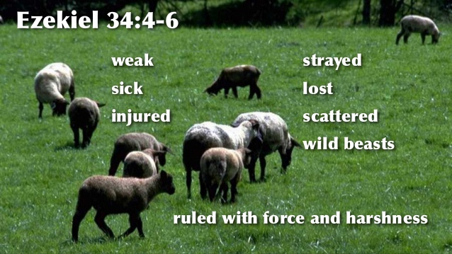

Wallace^{4*} calls the doing of justice and care for the needy the litmus test for God’s blessing or judgement on the people and their leaders. He reminds us that both Ezekiel and Matthew speak of judgement being a separating of the ones who do God’s will / follow Jesus, or not. Jesus separated the sheep from the goats, and Ezekiel separated the ‘fat’ from the ‘lean’ sheep. ^{off} “Both look to the establishment of what Matthew calls the ‘kingdom of heaven’. While that kingdom and the rule of Christ is seen as a future event, it is nevertheless reflected in the life of the Christian community today.”
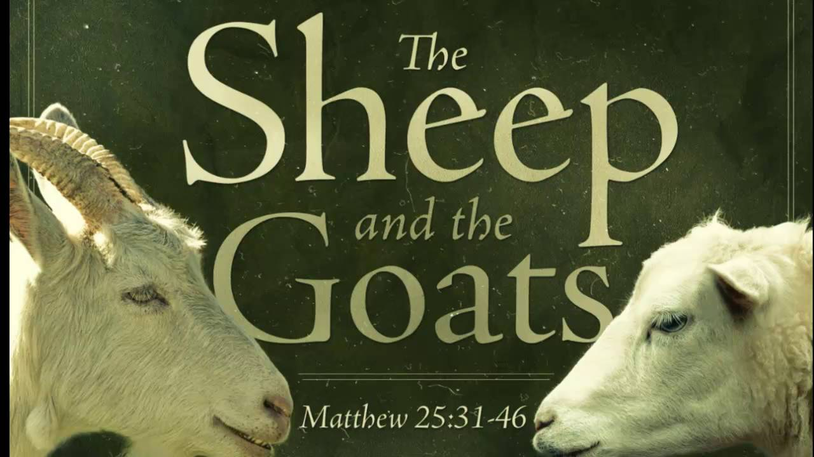

^{on} Have we learn enough of the ‘way’ that we will automatically live it out – not doing it for status, power, honour, etc becoming ‘fat’ with our efforts, but because it’s the best way to live and in following it we discover happiness, satisfaction and wholeness that belong to God’s saving plan for us. Are we up to the challenge of releasing ^{5*}“our obsession with sorting, to focus instead on seeing – seeing Christ in all people – and on serving – serving others as though they were Jesus himself.” ^{off}

If we can “then, we will have entered the reign of God without even trying and we will see and experience God’s reign in every place and every moment. The hard part is for us to make the conscious and difficult decision to recognise Christ in all others. It takes work and imagination, grace and a willingness to let go of our pride, our control and our natural tendency to stick with people like us.

It’s a scandalous truth – which Matthew’s readers must have choked on at first – that everyone belongs. It’s only those who cannot find a way to accept this who ultimately end up excluding themselves. The Shepherd really does welcome everyone, and those who are willing to follow the Shepherd’s example, discover this to be true for themselves.” ^{on}


“The reign of Christ, then, is not about seeing Jesus as some dominating despot, or conquering military victor. Rather, we are invited to see Christ’s reign as the gift of God’s grace, service and compassion that is available to all, and that we share with one another as we live as the body (the physical presence) of Christ in the world today.” “The question is how we can be the inclusive, God’s-reign-reflecting community that God’ in Christ calls us to be,” for then Christ is truly among us. Amen ^{off}

